PRE-SCHOOL VERSION
Welcome to St. Mary’s Church Scavenger Hunt! The following is intended for pre-school age children, to explore some of Walkley’s places, parks and streets, and earn a small Easter treat provided by Gerry the Baker. The suggested route is 1 mile and the hunt should take anywhere from 30minutes to 1.5hrs to do. For some questions there are no ‘right’ answers, for others, the answers are provided at the end. We encourage you to share some of the photos you may have collected on social media - the links to St. Mary’s social media are below. We hope you enjoy and … Happy Easter!
During the walk, try to get photos of things that are the same colour as the colours of the rainbow! (Red, Orange, Yellow, Green, Blue, Indigo, Violet - feel free to merge the last few together!)

1. After collecting this sheet, walk out of Gerry’s Bakery and turn right.
Can you spot the plant shop?
Take a picture of the most colourful thing you can see in there!

2. As you continue walking, you will see across the road that a new set of houses have recently been built called ‘Walkley Mews’
a. Do you know what shop used to be there?
b. What year was it built?

3. Cross Fir St. on your right
What number can you spot on the road sign?
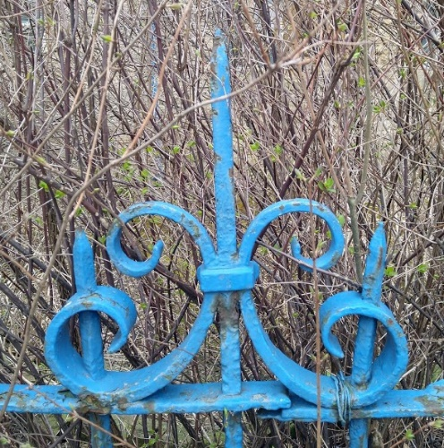

Can you find this?

4. Keep walking, can you spot this?
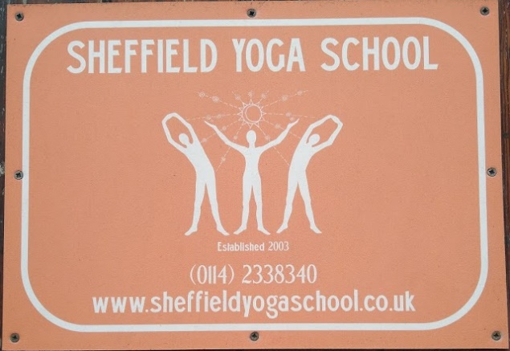

5. Stop at St Mary’s Church.
How many cuddly toys can you count in the windows? (How many have ‘bunny ears?)

Can you spot this?
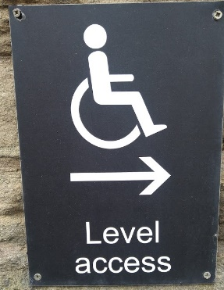
6. Keep walking along the church, can you find this special cross?
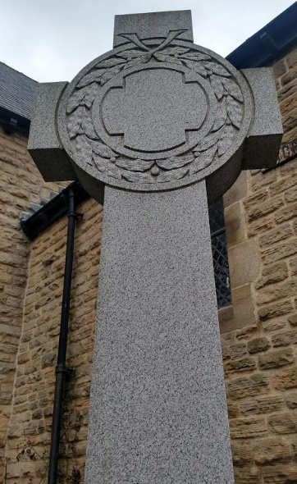

7. Cross the road carefully and carry on along South Road.
Can you spot this somewhere on your left?
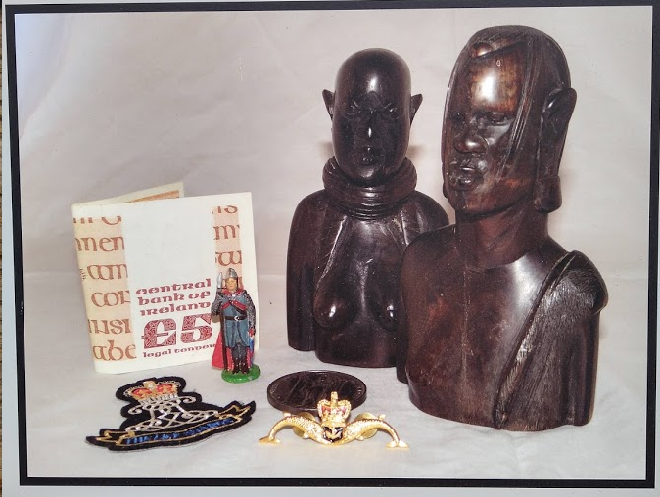

8. Turn left down Cromwell Street.
a) Can you spot a purple door?
b) What is on the door at no 44?
c) What is does the door knocker look like on no 36?

9. Turn right at the bottom and walk along Walkley St.
What colour is the door of no 39?
What colour are the numbers on the wheelie bins at no 9?

10. Keep going down the road where you join Daniel Hill Street.
You should now see some fields and a park to your left - take the path down through it towards the play park.
What is the name of the green park you are in?
What animals are trying to get into the playpark

11. Leave the park, exiting using the upper path, keeping the green
exercise equipment to your right
Keep walking until you get to St Mary’s School.

Can you spot this sign?
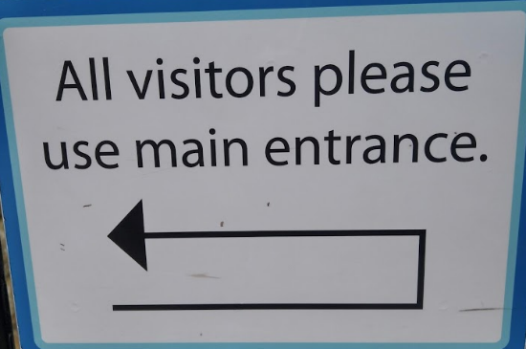

Look through the gate, can you see the big wooden pencils?
What colours can you spot?

12. Walk up the road.
How many doorbells can you count on the flats next to the school?

13. Keep walking up. What number is the Yoga Centre?
14. Can you spot this further up the road?
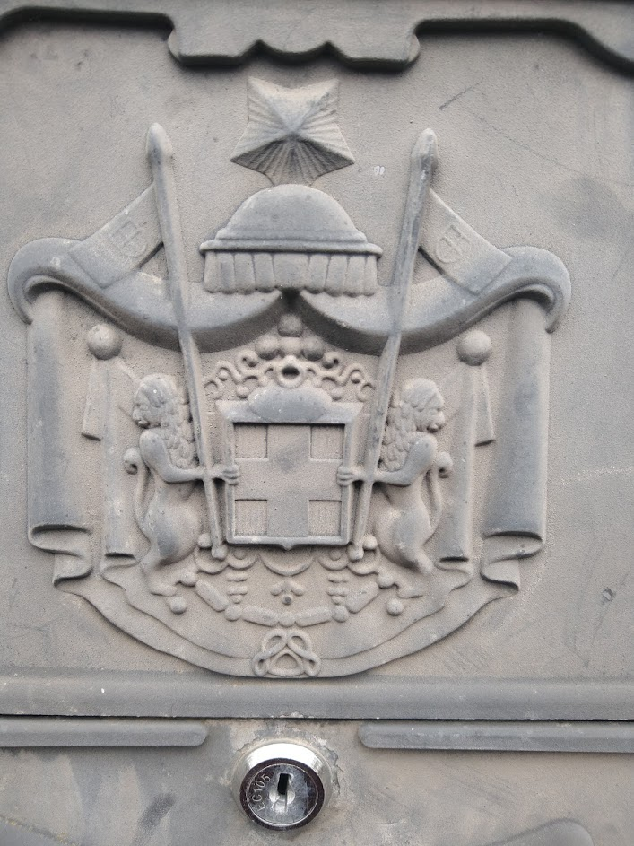

15. Keep going up until you again reach Walkley Street Turn right to continue along this road. There is a postbox on your right.
What letters can you spot on the postbox?

16. Carry on along Walkley Street.
a) What is the house at no 112 called?
b) What colour is no 126 painted?
c) What colour is the door of no 157?

17. Keep walking until you reach Industry Street. Turn left up this road.
a) What year was no 138 built?
b) What colour is the door of 169?
c) What is stuck onto door 180?
d) Can you spot this?
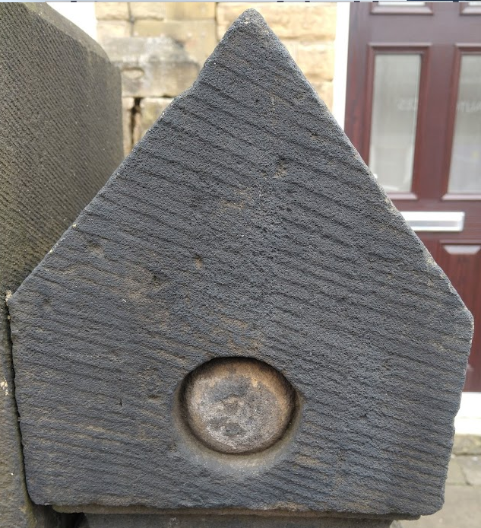

18. Keep walking until you reach Vito’s italian.
Can you spot this picture?

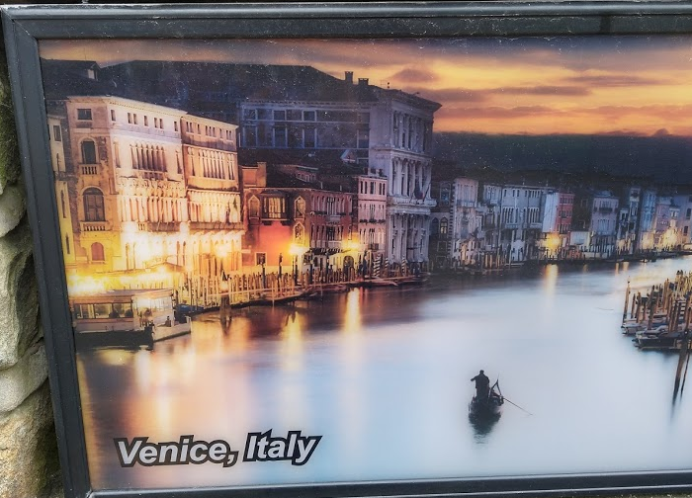

19. Turn right until you get to Beeches of Walkley. There is an old cash register in the window.
How many different coloured coins can you see?
How many pigs can you count in the other window?

20. Cross the road at the traffic lights to finally arrive back at Gerry’s bakery.
What’s hiding in the window?

You’ve worked really hard! Well done! Go and hand in your completed sheet and collect your winnings from Gerry! If the shop is closed, you can come back to collect your winnings another day!
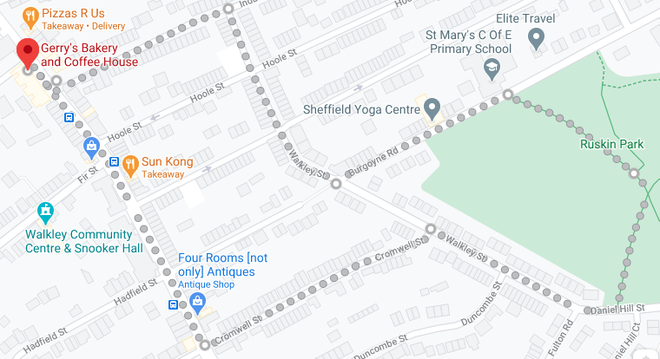

Answers:

- a) Albert Ross Salvage Emporium b) 2019
- 6

- 32 (4 with ears)

- a) 68 b) roses c) fox
- a) Blue b) Yellow
- a) Ruskin b) Bear, Fox, Rabbit, Owl
- a) dark blue, orange, red, green
- 12
- 270

- a) EIIR, W T Allen, LONDON
- a) The Royal b) White c) Red
- a) 1880 b) Green c) Fish Symbol

- a) 3 (Gold – half crown, Silver – sixpence, Bronze – penny/half penny) b) 42
- Red Origami Rabbit

