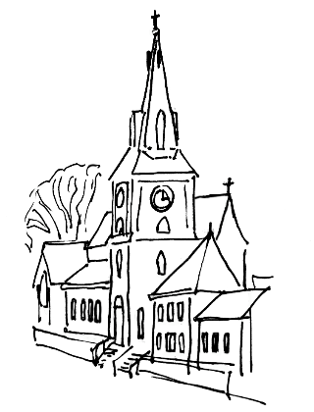
St Mary’s Church, Walkley

The Church on the Road:
Inclusive, Eucharistic, a safe place to be with God

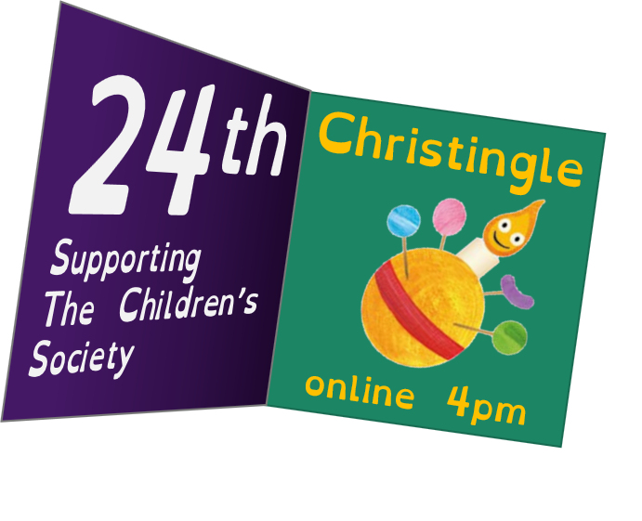

Christmas Eve

24th^{th} December 2020

Christingle service

Welcome to St Mary’s Church, Walkley

Welcome to everyone joining us online for our live-streamed Christingle service.

St Mary’s is a place of beauty and peace. It was built to the Glory of God, and to serve the community. It is the parish church of Walkley, part of the Church of England, and has a weekly pattern of “traditional” worship, including hymns, prayer and Holy Communion. St Mary’s preserves much of the history of Walkley and is a focus for community events. It is an excellent venue for concerts and exhibitions, and a resource for local schools. We are working to get the church open and available for anyone to enjoy throughout the day. The community hall adjoining the church provides disabled access and is available for hire.

Introduction to Christingle and The Children’s Society
Christingle is a candle-lit, festive celebration that’s perfect for bringing families and communities together. It was first invented by the Moravian church in the 1700s, but the celebration as we know it was brought to the Church of England by The Children’s Society in the 1960s.
The celebration is named after the Christingles that are lit during it. Christingles are made from an orange decorated with red tape, sweets and a candle. They have been part of our history for over 50 years and have helped raise millions of pounds to help this country’s most vulnerable children. Each year we ask those who celebrate Christingle to support children and young people in some of the darkest situations imaginable.
The Children’s Society
Founded in 1881 by Sunday School teacher Edward Rudolf, for the last 139 years The Children’s Society has supported millions of this country’s children and restored hope to their lives. They believe in building a society that works for every child, so that they are safe, happy and free to fulfil their incredible potential.
They run vital local services that provide vulnerable children across the country with the support, advice and guidance that they need, and they also campaign to make children’s lives better and change the systems that are placing them in danger.
Together with this country’s young people and their amazing supporters, The Children’s Society is improving life for children today and working to create a society where every child has hope for their future.

The Preparation

Minister Christ has brought us out of darkness
All To live in his wonderful light.

Forest Green
O little town of Bethlehem,
how still we see thee lie!
Above thy deep and dreamless sleep
the silent stars go by.
Yet in thy dark streets shineth
the everlasting light;
the hopes and fears of all the years
are met in thee tonight.
O morning stars, together
proclaim the holy birth,
and praises sing to God the King,
and peace to all the earth;
for Christ is born of Mary;
and, gathered all above,
while mortals sleep, the angels keep
their watch of wondering love.
How silently, how silently,
the wondrous gift is given!
So God imparts to human hearts
the blessings of his heav’n.
No ear may hear his coming;
but in this world of sin,
where meek souls will receive him, still
the dear Christ enters in.

O holy child of Bethlehem,
descend to us we pray;
cast out our sin, and enter in,
be born in us today.
We hear the Christmas angels
the great glad tidings tell:
O come to us, abide with us,
our Lord Emmanuel.
Phillips Brooks, 1835-1893

The Welcome

Minister Welcome to our Christingle service, in which we celebrate Jesus, the Light of the World, and the new life and hope he brings, and also raise money to support and awareness of the work of The Children’s Society, who bring light to the lives of young people who are suffering across this country. Today we have an opportunity during our Christingle service to celebrate Jesus, the Light, coming into a world of darkness, and to share that light with others.

The Lighting of the Advent candles

The four candles of the Advent wreath are lit.

Minister Jesus, Light of the World,
All Shine in this place.
Minister Jesus, Light of the World,
All Shine in our hearts.
Minister Jesus, Light of the World,
All Shine in our lives.
Minister Jesus, Light of the World,
All Shine in all the earth.
Amen.

We sit.

The Confession and Absolution

Minister In a dark and disfigured world
we have not held out the light of life:
Lord, have mercy.
All Lord, have mercy.

Minister In a hungry and despairing world
we have failed to share our bread:
Christ, have mercy.
All Christ, have mercy.

Minister In a cold and loveless world
we have kept the love of God to ourselves:
Lord, have mercy.
All Lord, have mercy.
(From New Patterns for Worship, B64)

Minister May God who loved the world so much
that he sent his Son to be our Saviour
forgive us our sins
and make us holy to serve him in the world,
through Jesus Christ our Lord.
All Amen.

The Reading: Luke 2. 1 - 20

In those days a decree went out from Emperor Augustus that all the world should be registered. This was the first registration and was taken while Quirinius was governor of Syria. All went to their own towns to be registered. Joseph also went from the town of Nazareth in Galilee to Judea, to the city of David called Bethlehem, because he was descended from the house and family of David. He went to be registered with Mary, to whom he was engaged and who was expecting a child. While they were there, the time came for her to deliver her child. And she gave birth to her firstborn son and wrapped him in bands of cloth, and laid him in a manger, because there was no place for them in the inn.
In that region there were shepherds living in the fields, keeping watch over their flock by night. Then an angel of the Lord stood before them, and the glory of the Lord shone around them, and they were terrified. But the angel said to them, ‘Do not be afraid; for see—I am bringing you good news of great joy for all the people: to you is born this day in the city of David a Saviour, who is the Messiah, the Lord. This will be a sign for you: you will find a child wrapped in bands of cloth and lying in a manger.’ And suddenly there was with the angel a multitude of the heavenly host, praising God and saying,
‘Glory to God in the highest heaven,
and on earth peace among those whom he favours!’
When the angels had left them and gone into heaven, the shepherds said to one another, ‘Let us go now to Bethlehem and see this thing that has taken place, which the Lord has made known to us.’ So they went with haste and found Mary and Joseph, and the child lying in the manger. When they saw this, they made known what had been told them about this child; and all who heard it were amazed at what the shepherds told them. But Mary treasured all these words and pondered them in her heart. The shepherds returned, glorifying and praising God for all they had heard and seen, as it had been told them.

Reader This is the word of the Lord.
All Thanks be to God.

We stand.

Sweet bells
While shepherds watched their flocks by night,
all seated on the ground,
the angel of the Lord came down,
and glory shone around.
Sweet Bells. Sweet chiming Christmas Bells,
Sweet Bells, Sweet chiming Christmas Bells,
They cheer us on our Heavenly way sweet chiming bells.

‘Fear not,’ said he (for mighty dread
had seized their troubled mind);
‘glad tidings of great joy I bring
to all of humankind.’
Sweet Bells. Sweet chiming Christmas Bells,
Sweet Bells, Sweet chiming Christmas Bells,
They cheer us on our Heavenly way sweet chiming bells.

To you in David’s town this day
is born of David’s line
a Saviour, who is Christ the Lord;
and this shall be the sign:
Sweet Bells. Sweet chiming Christmas Bells,
Sweet Bells, Sweet chiming Christmas Bells,
They cheer us on our Heavenly way sweet chiming bells.

The heavenly babe you there shall find
to human view displayed,
all meanly wrapped in swathing bands,
and in a manger laid.’
Sweet Bells. Sweet chiming Christmas Bells,
Sweet Bells, Sweet chiming Christmas Bells,
They cheer us on our Heavenly way sweet chiming bells.

Thus spake the seraph, and forthwith
appeared a shining throng
of angels praising God, who thus
addressed their joyful song:
Sweet Bells. Sweet chiming Christmas Bells,
Sweet Bells, Sweet chiming Christmas Bells,
They cheer us on our Heavenly way sweet chiming bells.

‘All glory be to God on high,
and to the earth be peace;
goodwill henceforth from heaven to all
begin, and never cease.’
Sweet Bells. Sweet chiming Christmas Bells,
Sweet Bells, Sweet chiming Christmas Bells,
They cheer us on our Heavenly way sweet chiming bells.

Nahum Tate, 1652-1715
based on Luke 2. 1-20

We sit.

The Homily

We stand.

Away in a manger, no crib for a bed,
the little Lord Jesus laid down his sweet head;
the stars in the bright sky looked down where he lay,
the little Lord Jesus asleep on the hay.

The cattle are lowing, the baby awakes,
but little Lord Jesus no crying he makes.
I love thee, Lord Jesus! Look down from the sky,
and stay by my side until morning is nigh.

Be near me, Lord Jesus; I ask thee to stay
close by me for ever, and love me, I pray.
Bless all the dear children in thy tender care,
and fit us for heaven, to live with thee there.

Author Unknown
Little children's book, Philadelphia, 1885

The Prayers of Intercession

Minister Lord Jesus,
you were born into an ordinary family:
We pray for families everywhere,
especially for families in difficulty or in poverty,
and for families and relationships that are breaking down.
Lord, in your mercy,
All Hear our prayer.

Minister Lord Jesus,
your bed was in a manger,
because there was no room at the inn.
We pray for all those who have no home:
those who sleep on the streets,
and all who have lost everything
through violence or disaster.
Lord, in your mercy,
All Hear our prayer.

Minister Lord Jesus,
the animals shared their stable with you;
We pray for the earth, and for all living things,
that we might learn to live in peace and harmony with the natural world,
and treat all of creation with honour and respect.
Lord, in your mercy,
All Hear our prayer.

Minister Lord Jesus,
you were worshipped and adored by shepherds and kings:
We pray for the people and nations of the world,
and especially for peace and understanding
between different faiths.
You came as the light for the whole world,
so in you may we find that we have more in common
than that which divides us.
Lord, in your mercy,
All Hear our prayer.

Minister Lord Jesus, God with us,
we pray for people we know who are in need.
We pray especially for children who are in difficulty,
and for the work of The Children’s Society
in standing up for justice
and bringing light and hope into darkness.
Help us to show to one another
the same faithfulness and love
that you revealed at Bethlehem.
Lord, in your mercy,
All Hear our prayer.

Minister Lord Jesus,
you came to be with us on earth
so that we might be with you in heaven:
Keep safely all those who have died.
Lord, in your mercy,
All Hear our prayer.

The Lord’s Prayer

Minister We say together the prayer that Jesus taught us:

All Our Father in heaven,
hallowed be your name,
your kingdom come,
your will be done,
on earth as in heaven.
Give us today our daily bread.
Forgive us our sins
as we forgive those who sin against us.
Lead us not into temptation
but deliver us from evil.
For the kingdom, the power,
and the glory are yours
now and for ever.
Amen.

We stand.

Presentation and Lighting of the Christingles
As we light our Christingles in church, please light your Christingle at home.
The Christingle prayer:
Minister Lord Jesus,
Light of the world,
I hold this Christingle as a sign of your love.
All May we share your light in the darkness.

Minister The candle, planted deep within the world,
as a sign that you made your home among us,
and lived with the poor and neglected.
All May we share your light in the darkness.

Minister The ribbon, wrapped around the earth,
a sign of your love shown on the cross,
enfolding the whole world with your saving love.
All May we share your light in the darkness.

Minister The fruits and sweets,
signs of all the good things you have made,
given to us that we might share them fairly
so everyone can have enough.
All May we share your light in the darkness.

Lord Jesus,
Light of the World,
as I hold this Christingle
and think about your great love for me,
help me to take this light out into the world
and to share your love with others,
especially those who need it most. Amen.

We stand.

O come all ye faithful,
joyful and triumphant,
O come ye, O come ye to Bethlehem;
come and behold him,
born the King of angels:
O come, let us adore him,
O come, let us adore him,
O come, let us adore him,
Christ the Lord!

God of God,
Light of Light,
Lo! He abhors not the Virgin's womb;
very God,
begotten, not created:
O come, let us adore him,
O come, let us adore him,
O come, let us adore him,
Christ the Lord!

See how the shepherds,
summoned to his cradle,
leaving their flocks, draw nigh with lowly fear;
we too will thither
bend our joyful footsteps:
O come, let us adore him,
O come, let us adore him,
O come, let us adore him,
Christ the Lord!

Sing, choirs of angels,
sing in exultation,
sing, all ye citizens of heaven above;
Glory to God in the highest:
O come, let us adore him,
O come, let us adore him,
O come, let us adore him,
Christ the Lord!

Words: Latin, 18th century
Tune: Adeste fideles

The Sending Out

All We go in peace:
To share the peace of God with all we meet.
We go in love:
To share God’s gift of love with the world.
We go in the light of Christ:
To shine as lights in the world.
To the glory of God the Father.
Amen.

We’re glad you could join us online. Merry Christmas and a Happy New Year!

If you would like to find out more about The Children’s Society, please visit childrenssociety.org.uk. To make a donation to the Children’s Society via the St Mary’s Christingle page, go to: https://thyg.uk/CUS049481
This order of service was produced by The Children’s Society XTC154a/0820 © The Children’s Society 2020. Charity Registration No. 221124 Adapted for local use

